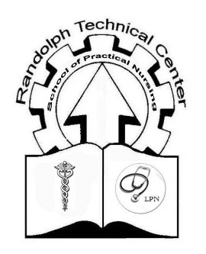
TESTING AND CLASSES INFOMATION SHEET

All LPN applicants are required to take a TABE assessment in the areas of Reading and Mathematics. Students may use TABE assessment scores from Work Force if the exam was taken within the last six
months prior to August 1, 2019. In other words, assessment scores before March 1, 2019 will not be accepted and you will need to retake the exam. You are required to bring Work Force assessment scores to the AE classroom which is located behind the Randolph Technical Center. Your TABE scores will be reviewed and additional TABE testing may be required at a later date. You will also need to complete paperwork if you are planning on taking classes and the PSB exam. If you are only doing testing, including the PSB, you are still required to do paperwork for the Adult Learning Center so that test scores and information can be shared with the LPN program and/or Work Force. If you are taking the initial TABE assessment at the Randolph Technical Center on the assigned date, August 1, then you may complete your paperwork at that time. Score requirements will be discussed with you, as well as reminders regarding class dates and the PSB exam dates.

TABE PRETEST (Reading and Mathematics)
Last Name: A-M (August 1, 2019) 9:00 am Conference Room Randolph Technical Center
Last Name: N-Z (August 1, 2019) 1:00 pm Conference Room Randolph Technical Center

Students must take both the pre- and post- TABE tests in reading and math, in order to qualify for the PSB test.

TABE POSTTEST (Reading and Mathematics)
Last Name: A-M (September 26, 2019) 9:00 am Conference Room Randolph Technical Center
Last Name: N-Z (September 26, 2019) 1:00 pm Conference Room Randolph Technical Center

PSB Exam Dates (Please mark your calendar; there are no alternative testing dates for this exam.)
Last Name: A-M (October 1, 2019) 3:30 pm Conference Room Randolph Technical Center
Last Name: N-Z (October 2, 2019) 3:30 pm Conference Room Randolph Technical Center

Classes are available and free of charge for LPN applicants. Attendance is required for materials. Additional classes may be offered, depending on class and student needs.
Classes will be at the Randolph Technical Center at 3:30 pm on the following dates:

August 5
August 12
August 19
August 26
September 16
September 23
September 30

Any questions, please feel free to contact: Randolph Technical Center / AE
304-636-9195 (ext 110)
Randolph Technical Center / LPN
304-636-9195 (ext 115)

