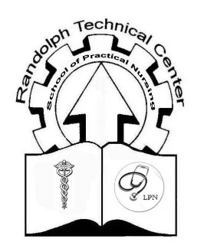
Randolph Technical Center
School of Practical Nursing
200 Kennedy Drive
Elkins, WV 26241
Phone: (304) 636-9195 Ext 115
Fax: (304) 636-9169

Transcript Request Form
(Mail this completed form to the Nursing Program Secretary)

Please Print or type:

Last Name at time of graduation: ____________________________________

First Name and Middle Initial: ____________________________________

Year of Graduation: ____________________________________

Phone Number: ____________________________________

Date of Birth: ____________________________________

Please send an official copy of my transcript to the following facility/college:
(all information must be completed)

Name of Facility/College: _____________________________________

Address: _____________________________________
Street

_____________________________________
City State Zip

Signature: _____________________________________________ Date: __________

Cost $5.00 per transcript
For Office Use Only:

Date received: __________

Date issued: __________

